VERSION CONTROL GIT-ASSIGNMENT

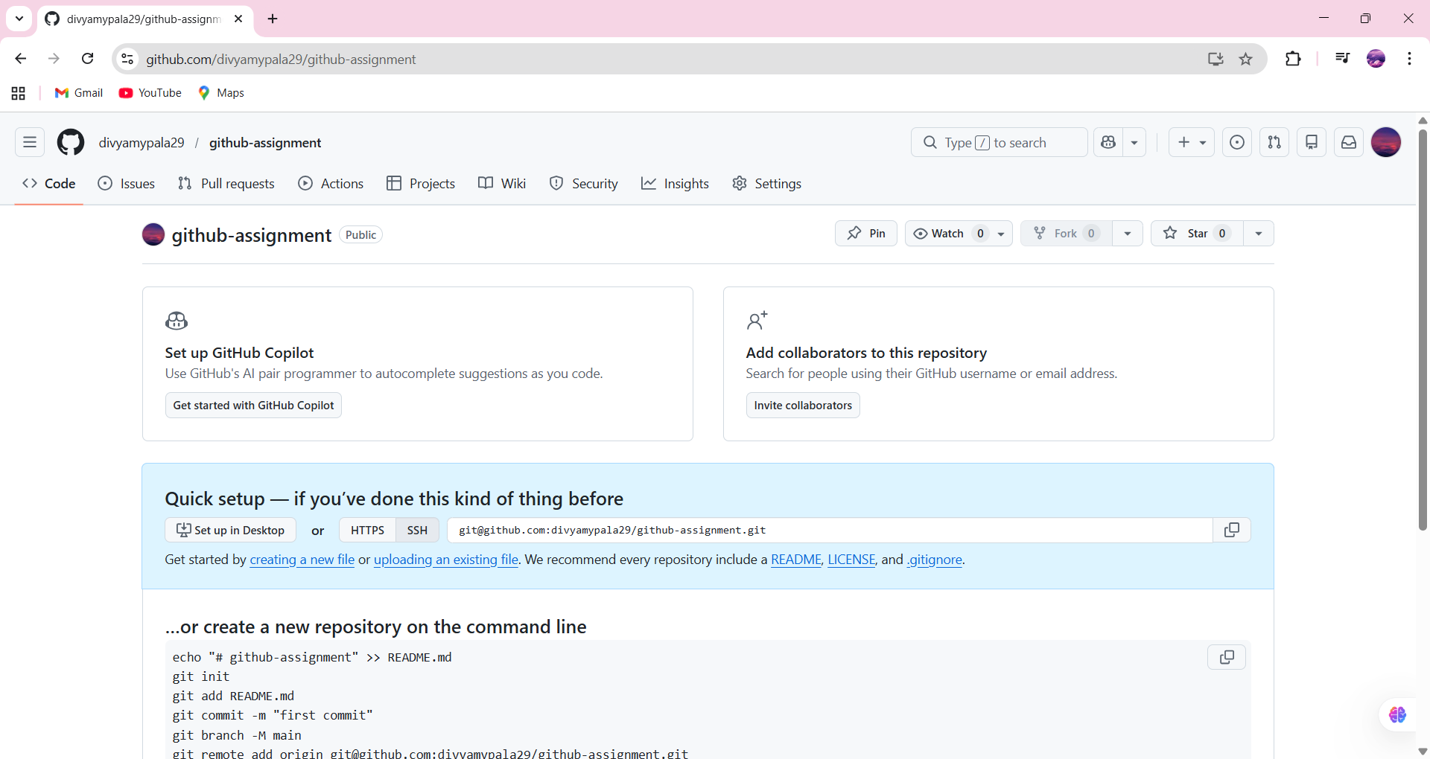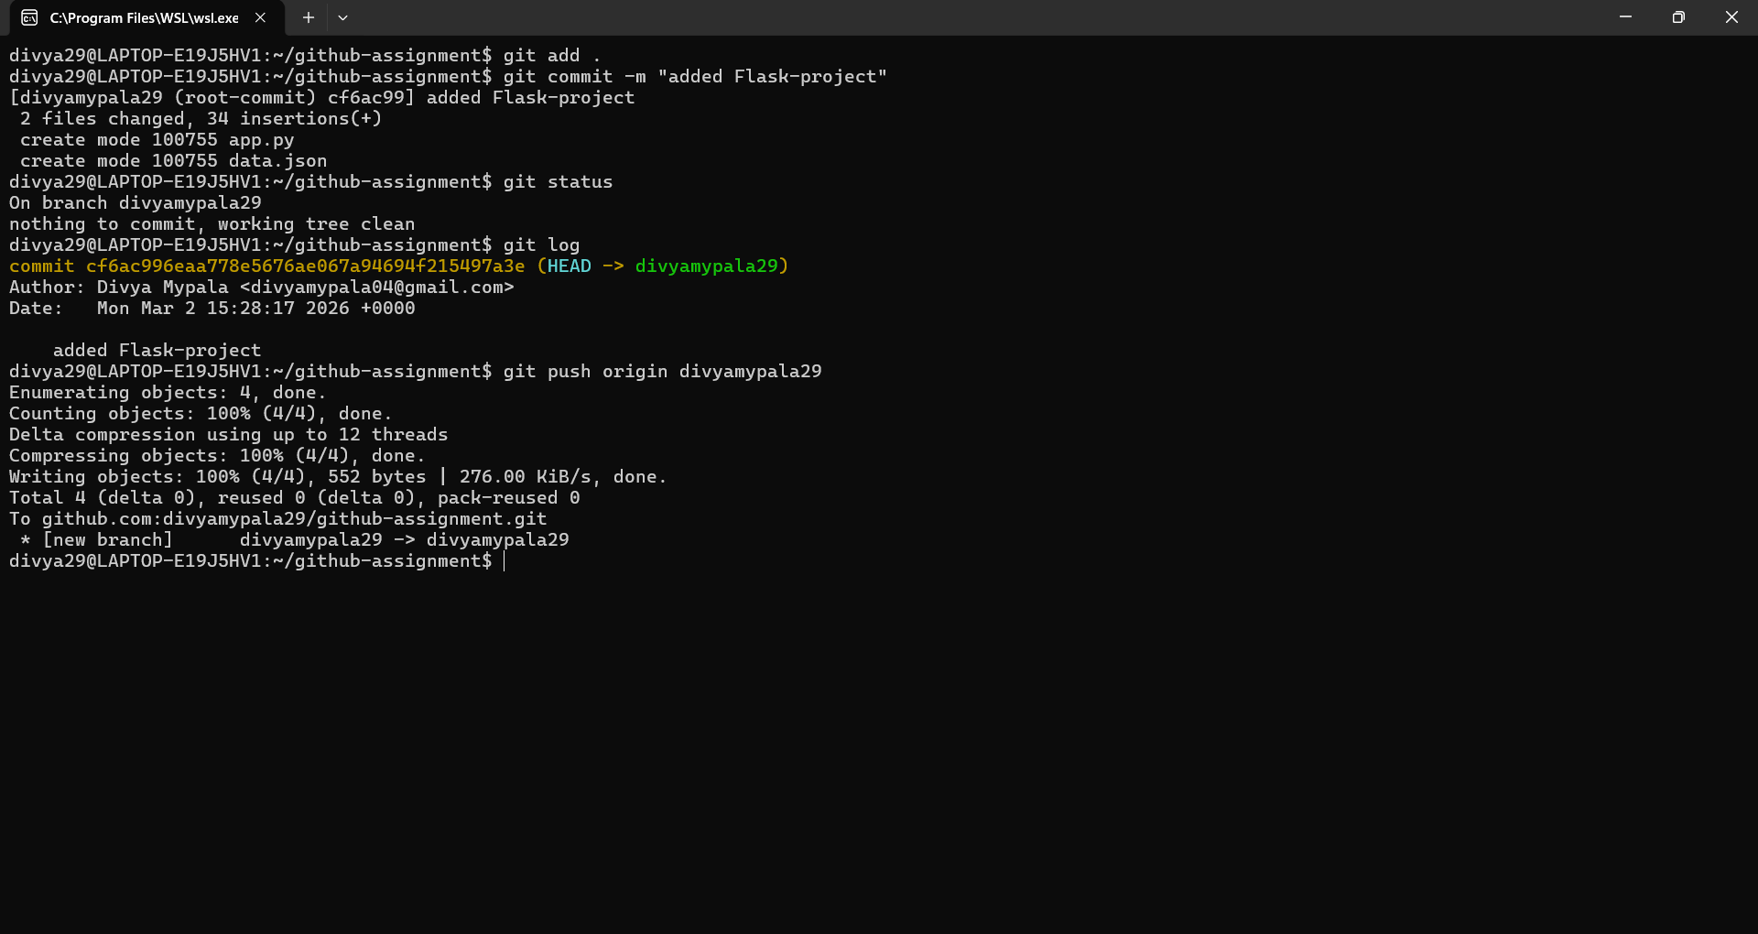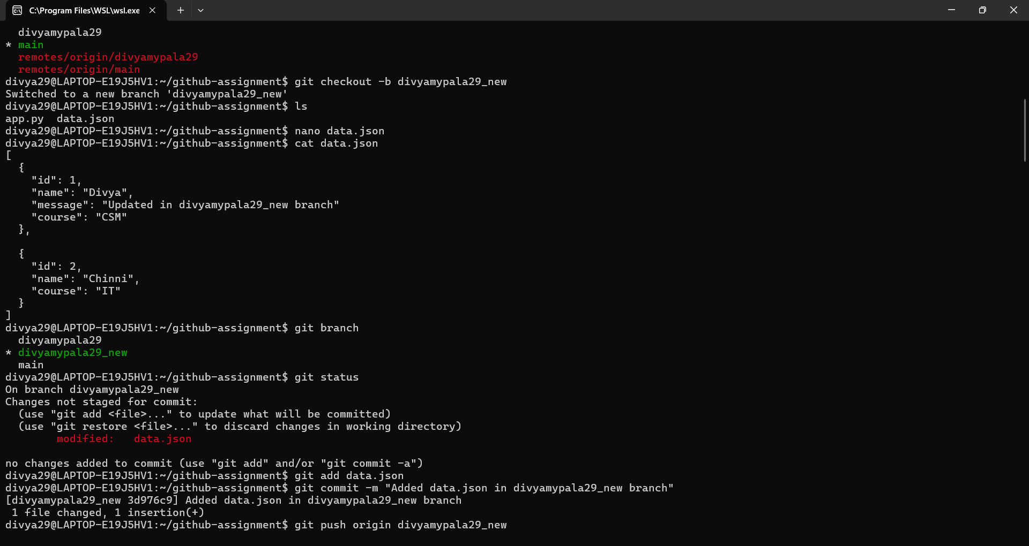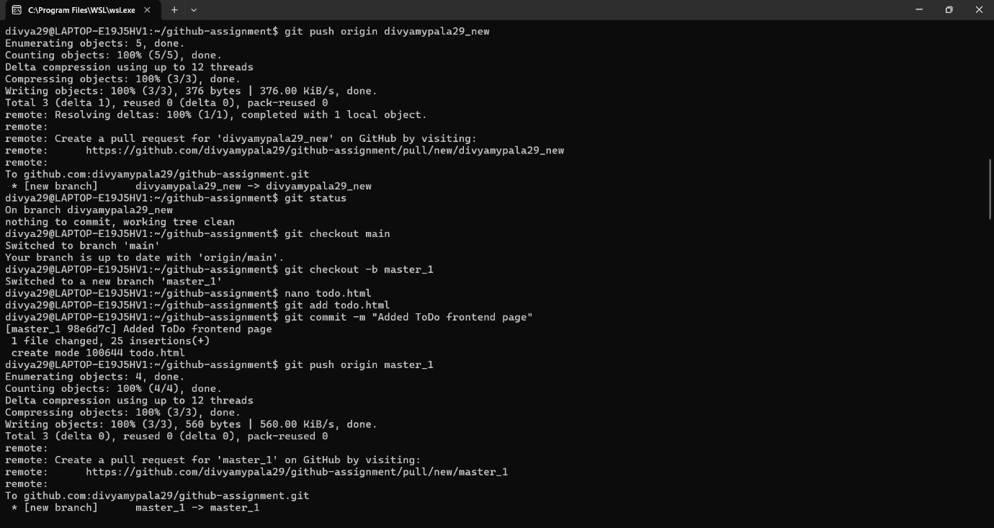
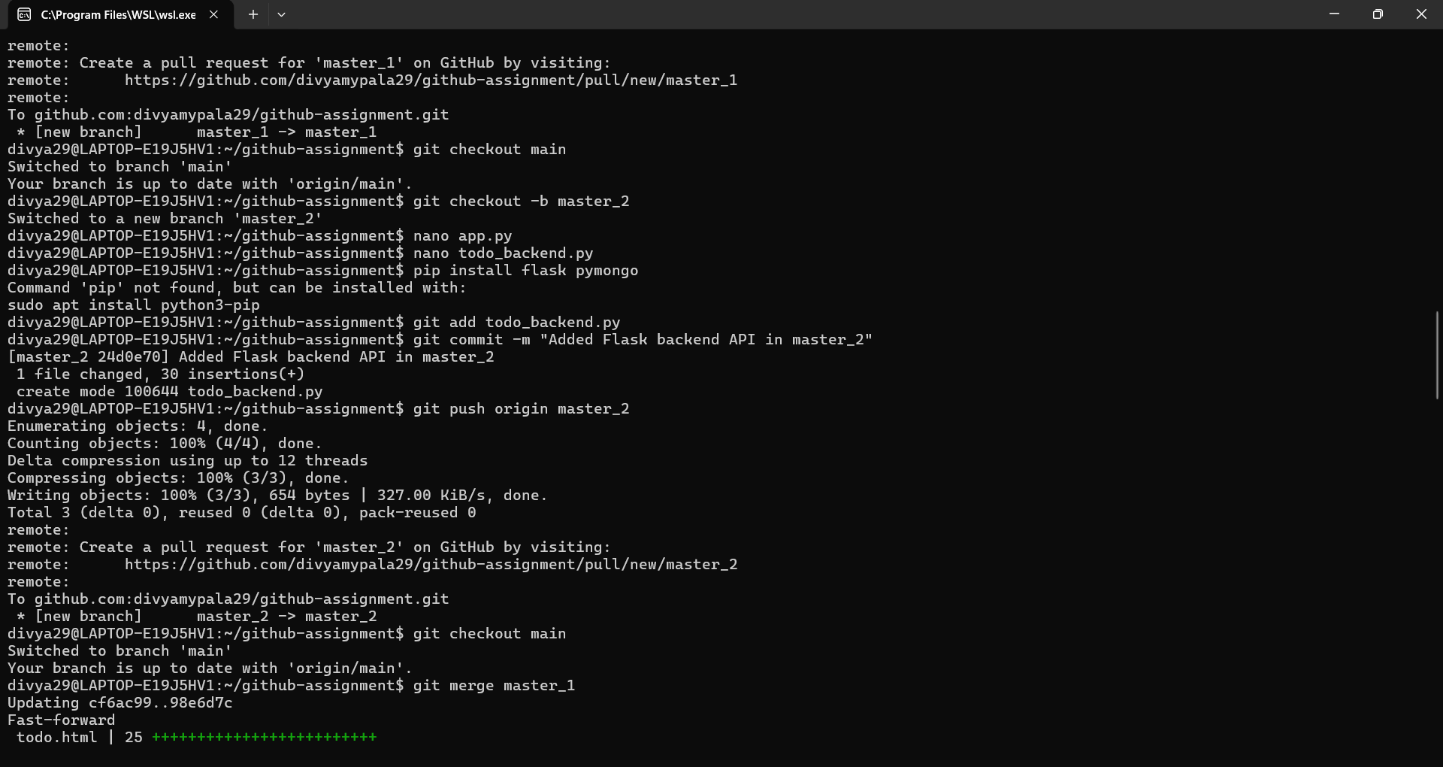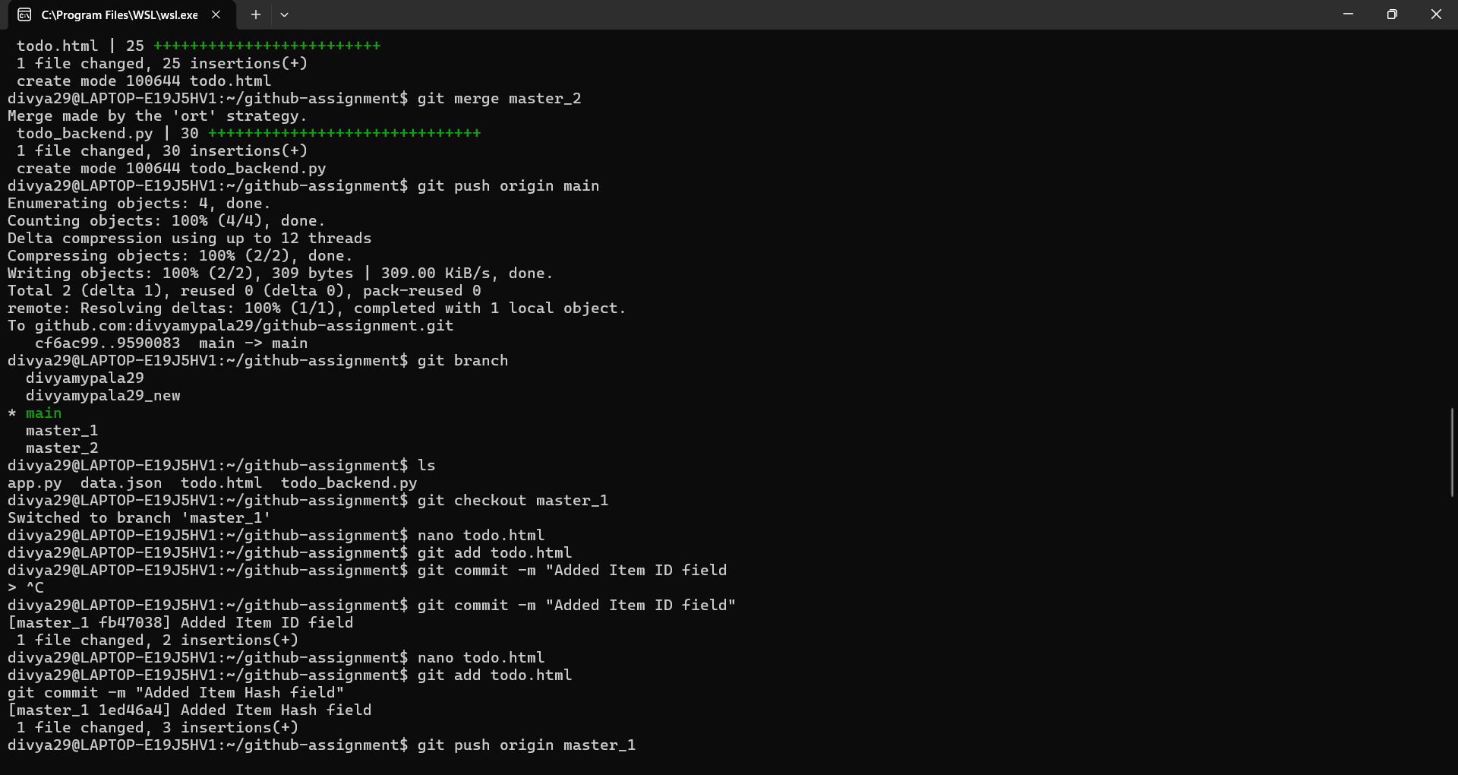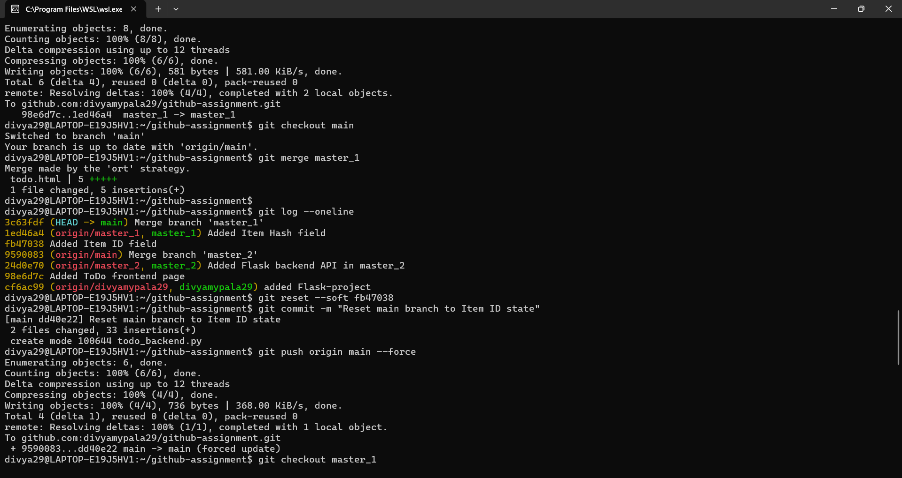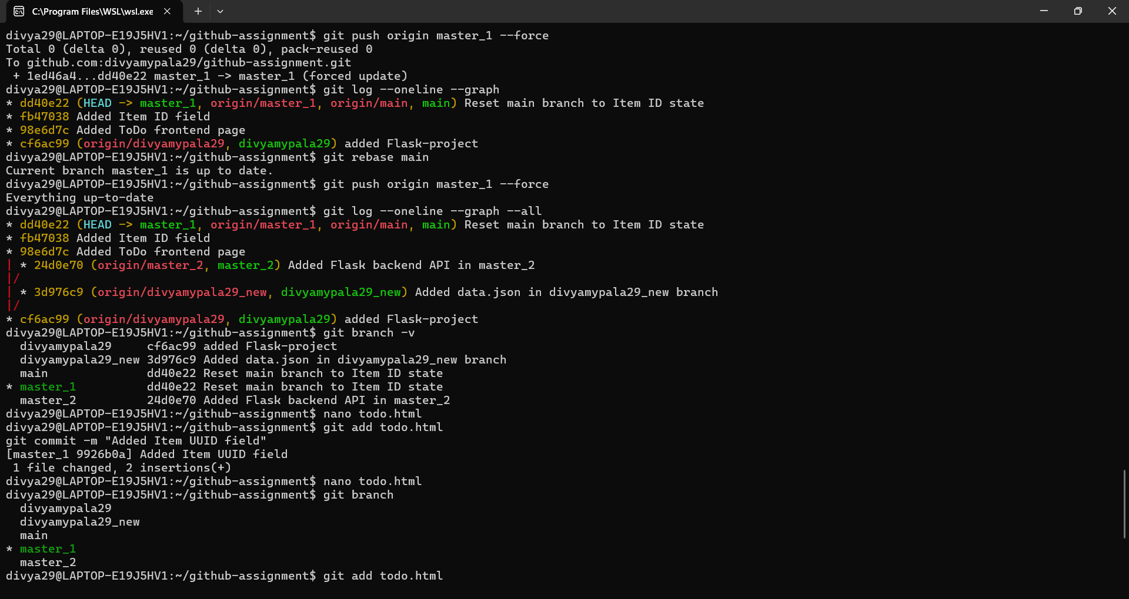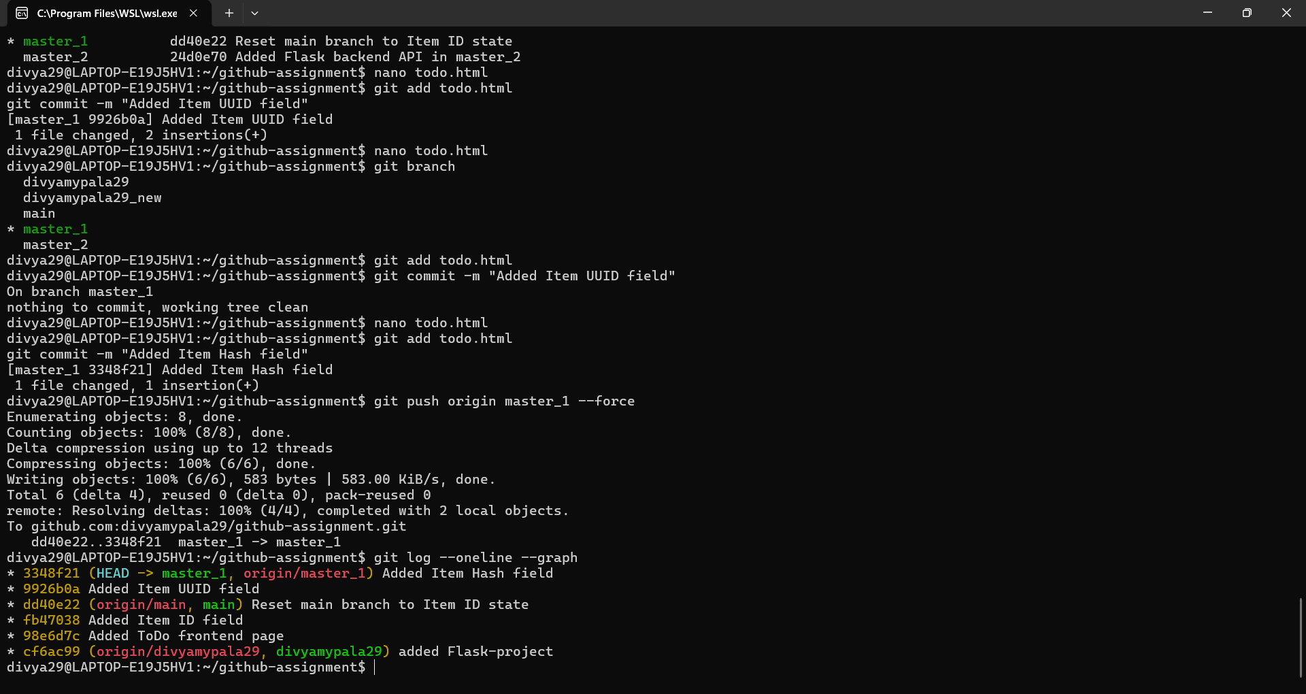

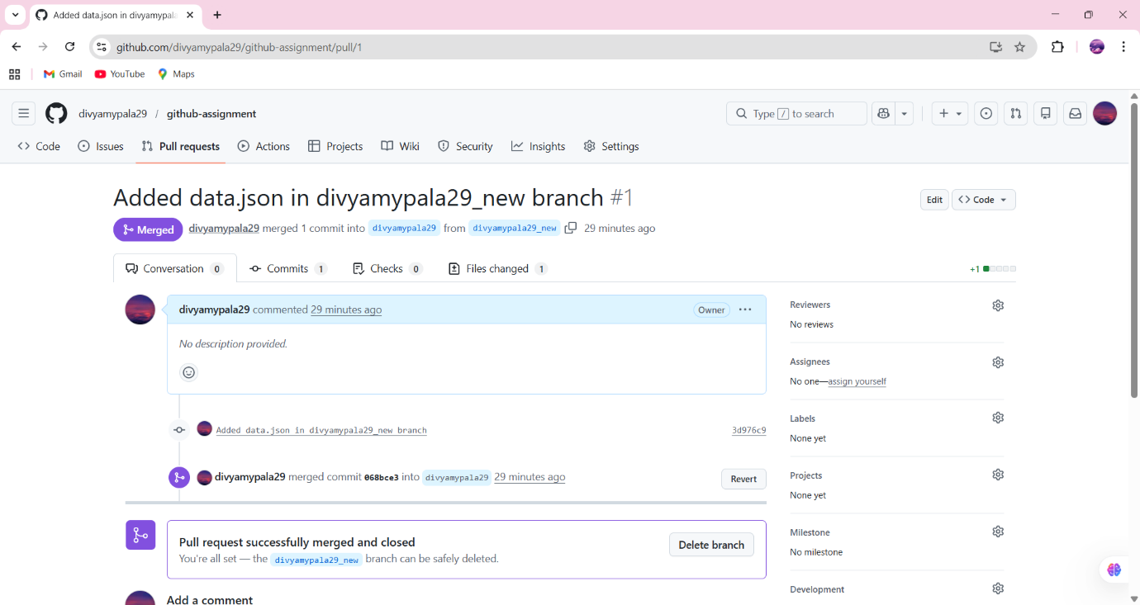

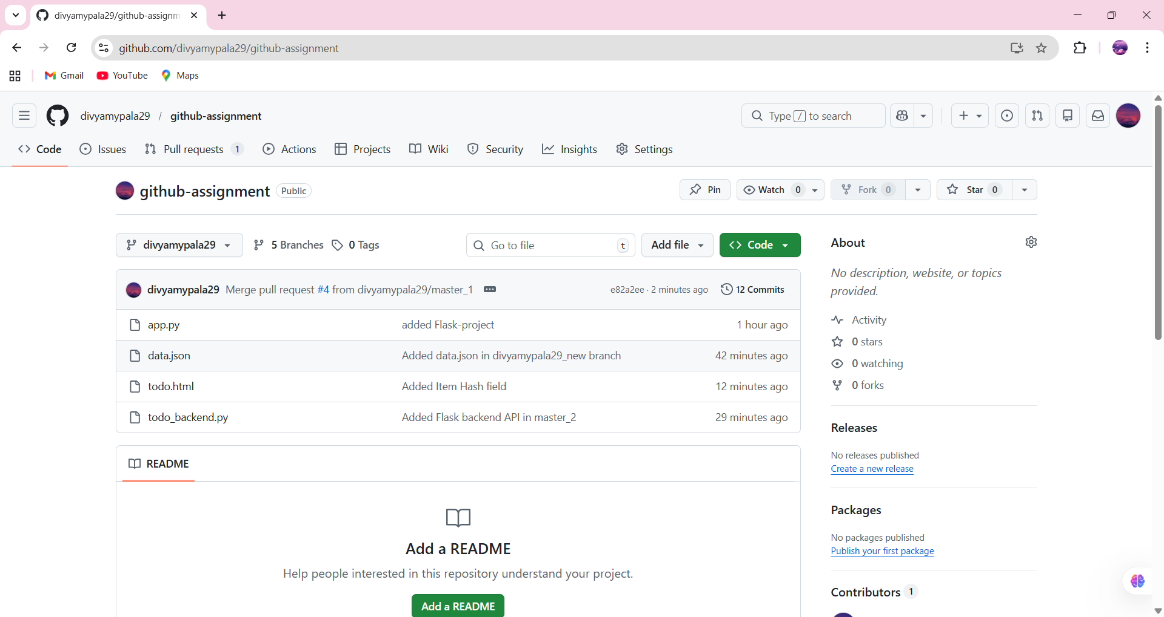

I started the assignment by creating the required branches from the main branch and working on them separately. In the master_1 branch, I developed the To-Do form page using HTML and added the required fields step by step. Firstly, I added the Item ID field and committed it, then I added the Item UUID field and committed it, and finally I added the Item Hash field and committed it, so that each change was saved in sequence. In the master_2 branch, I created the backend API using Flask to accept the form data and store it in the MongoDB database. After completing the frontend and backend tasks, I merged the branches into the main branch. Then, as instructed, I used git reset --soft to roll back the main branch to the commit where only the Item ID field was added, and I recommitted that state. Finally, I rebased the changes from the main branch into the master_1 branch to maintain a proper commit history without losing the individual commits

